**RELINING AND REBASING**

**Relining:** The procedures used to resurface the tissue side of a denture with a new material layer, thus producing an accurate adaptation to the denture foundation area. (Minimal to moderate changes).

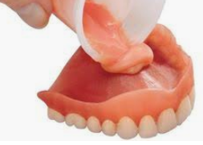

**Rebasing:** The laboratory process of replacing the entire denture base material on an existing prosthesis. (Moderate to maximal changes).

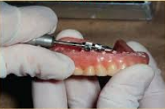

**The indication of relining or Rebasing.**

Observed clinical changes include:

* Less of retention and stability
* Loss of vertical dimension of occlusion.
* Loss of support for facial tissues.
* Horizontal shift of dentures: incorrect occlusal relationship.
* Reorientation of occlusal plane.

**Contraindication of relining and rebasing.**

1. When there is increased vertical dimension (insufficient interarch space).

2. Poor esthetic and incorrect position of teeth.

3. Unsatisfactory jaw relationship in the denture.

4. Excessive resorption of residual ridge.

5. Sever osseous undercuts.

6. Dentures causing major speech problems.

7. Temperomandibular joint problems.

**Laboratory procedure**

1- Beading and boxing of the impression, then pouring the boxed impression with stone material.

2- The denture and the cast are not separated, but any excess impression on the teeth or facial surfaces of the base is removed, then the denture flasked in the usual manner.

3- We do wax elimination by heating in hot water for 5 minutes, and then separated and all the impression material is cleaned from the cast and the denture base.

4- Painting the cast with a separating medium (cold mold seal).

5- Paint the surface of the denture with cotton pellet moistened with monomer.

6- Mix the acrylic resin and place it in the flask.

7- Curing for 9 hours at 165 F.

8- The denture deflasked and the cast removed from the denture, then polish the denture and remount the cast.

9- The maxillary and mandibular dentures are remounted on articulator after correction of occlusion; the relined denture is ready to be inserted in the patient mouth.

**The chair side relines technique**

Several attempts have been made to produce an acrylic or other plastic material that can be added to the denture and allowed to set in the patient mouth, but these have been failed for several reasons:

1- The material has often produced a chemical burn on the mucosa (exothermic reaction).

2- Color stability is very low, and bad odor due to porosity of the mat since no flasking procedure is used.

3- Liability for errors and wrong positioning of the denture is great.

4- Improvement in the denture requirement is very little and low.

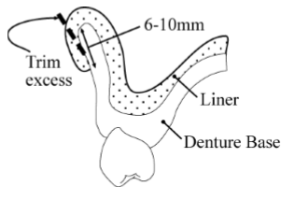 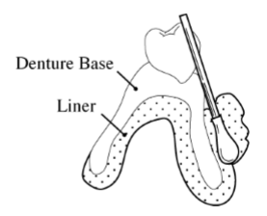

**Rebasing**

Rebasing procedure is the same as those for relining with some differences:

1. Impression is made and a cast is poured in the denture as in relining procedure.

2. The denture with cast is mounted on an instrument as Hooper duplicator that maintains the relationship of teeth to the cast.

3. The old denture is destroyed and removed.

4. The original teeth are re-waxed in their previous position on the cast.

5. The denture is then processed in the laboratory as for relining.