**Lecture 4**

RBCs: Definition, Structure, and Normal Value;

Hb, Definition, Structure, and Normal Value;

Blood Groups

**Definition**: Red blood cells (RBCs), also known as erythrocytes, have a unique structure that is specialized for their primary function: carrying oxygen from the lungs to tissues throughout the body and returning carbon dioxide to the lungs for exhalation.

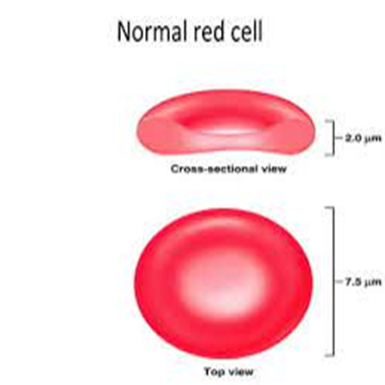 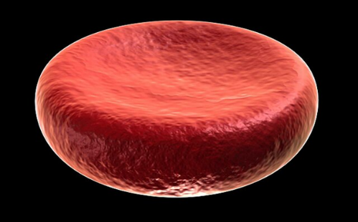

1. Biconcave Disc Shape: Red blood cells are small, flexible, and biconcave in shape, resembling a flattened disk with a thinner center and thicker edges. This shape provides them with a large surface area-to-volume ratio, allowing for efficient gas exchange.
2. Lack of Nucleus and Organelles: Mature red blood cells do not contain a nucleus, mitochondria, or other organelles. The absence of a nucleus maximizes their space for carrying hemoglobin.
3. Hemoglobin: Hemoglobin is the protein found in red blood cells and is responsible for binding and transporting oxygen. Each hemoglobin molecule contains four heme groups, each of which can bind to one molecule of oxygen. Hemoglobin gives red blood cells their characteristic red color.
4. Plasma Membrane: The plasma membrane, also known as the cell membrane, surrounds the red blood cell. It is made up of lipids and proteins and is responsible for maintaining the cell's shape and flexibility.
5. Cytoplasm: The cytoplasm of red blood cells is a gel-like substance that contains dissolved ions and enzymes necessary for maintaining the cell's integrity and function. It also contains enzymes involved in glycolysis, the metabolic pathway that generates energy for the cell in the absence of mitochondria.
6. Lifespan: Red blood cells have a finite lifespan, typically around 120 days in circulation. After this time, they are removed from the bloodstream by the spleen and liver, and new red blood cells are continuously produced by the bone marrow to replace them.
7. Flexibility: The biconcave shape and flexibility of red blood cells allow them to squeeze through narrow capillaries and navigate the circulatory system smoothly without getting stuck or causing blockages.
8. No Cell Division: Unlike most cells in the body, mature red blood cells do not undergo cell division (mitosis). Instead, they are continually produced by specialized cells in the bone marrow called hematopoietic stem cells.

**Normal Value**

Normal red blood cells having a mean diameter of about 7.8 micrometers and a thickness of 2.5 micrometers at the thickest point and 1 micrometer or less in the center. The average volume of the red blood cell is 90 to 95 cubic micrometers.

In normal men, the average number of red blood cells per cubic millimeter is 5,200,000 (±300,000); in normal women, it is 4,700,000 (±300,000).

Persons living at high altitudes have greater numbers of red blood cells.

**Hemoglobin definition**

Hemoglobin, often abbreviated as Hb, is a protein found in red blood cells (erythrocytes) that plays a crucial role in the transportation of oxygen from the lungs to the body's tissues and organs and the transportation of carbon dioxide from the tissues back to the lungs for exhalation. Hemoglobin is responsible for its red color.

**Structure of hemoglobin**

The structure of hemoglobin is composed of four subunits, each containing a heme group.

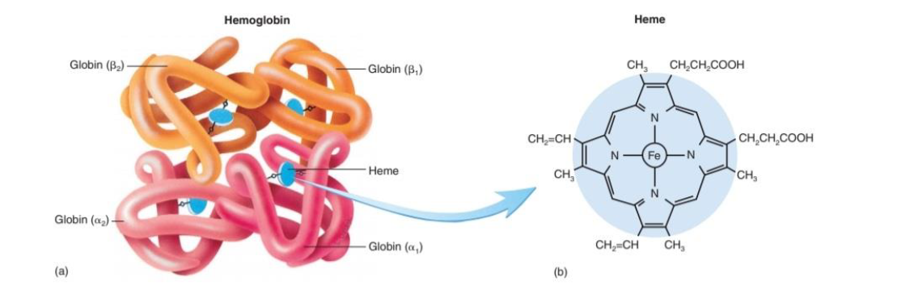

**Protein Subunits**: Hemoglobin is made up of four protein subunits, two of which are called alpha (α) globin chains, and the other two are called beta (β) globin chains. These subunits are held together by various types of interactions, including hydrogen bonds, hydrophobic interactions, and electrostatic interactions.

**Heme Groups**: Each of the four subunits of hemoglobin contains a heme group. A heme group is a complex structure that includes an iron ion (Fe^2+) at its center. It is the iron ion that binds with oxygen molecules (O2). There are four heme groups in a hemoglobin molecule, and each can bind to one molecule of oxygen.

**Oxygen Binding and Release**: Hemoglobin has a high affinity for oxygen when the iron ions in its heme groups are in the ferrous (Fe^2+) state. When oxygen binds to one heme group, it causes a conformational change in the hemoglobin molecule, making it easier for the other heme groups to bind with oxygen. This property allows hemoglobin to efficiently pick up oxygen in the lungs and release it in the peripheral tissues where oxygen is needed.

**Hemoglobin value**

Whole blood of men contains an average of 15 grams of hemoglobin per 100 milliliters of cells; for women, it contains an average of 14 grams per 100 milliliters.

Each gram of pure hemoglobin is capable of combining with 1.34 milliliters of oxygen.

Therefore, in a normal man, a maximum of about 20 milliliters of oxygen can be carried in combination with hemoglobin in each 100 milliliters of blood, and in a normal woman, 19 milliliters of oxygen can be carried.

**Blood groups**

The two most important blood group systems are:

1. ABO blood group system
2. Rh blood group system

