**Flexible Endoscope**

Optical fibers have had a profound effect on the advancement of endoscopy and, in this process, dramatically changed the practice of medicine and surgery. These small, flexible light bundles, comprising single fibers, between 50 and 100 nm, allow physicians to direct light into those places in the body where it was not earlier considered possible. The fiber optic bundle transports light from the light source to the investigation point, preventing the light source's heat from affecting the illuminated tissue. This is referred to as a 'cold light source,' which provides high-intensity light to the endoscope's distal tip. The flexible bundle of thin, multiple optical fibers can be constructed to allow the transmission of images and even to direct laser light to perform microsurgeries in regions that are otherwise too delicate or intricate to access.

Optical fibers are narrow tubes of glass fibers with a plastic coating that carry light from one end to the other. The light bounces off the walls of the fiber and can even bounce around corners. The light rays travel along the fibers based on total internal reflection. An array of different light delivery devices is now available that can be used with an endoscope. Conventional silica glass fibers transmit wavelengths from the visible (400 nm) to the mid-infrared (2.5 mm) range. New solid-core fibers are available for the transmission of infrared wavelengths that include fluoride glass, sapphire (up to 5 mm), and silver halide fibers (up to 30 mm). The endoscope comes with a cold light bulb and a flexible optic cable, which allows for a field of vision of up to 80°. The endoscope cable is provided with markings, which allow the user to determine the depth of penetration and to make it easier to locate the observed area. The brightness of the field of vision can be adjusted with the help of an external control. An endoscope has four basic components:

A light source: For illumination of the object to be studied.

A tube: That guides the light to the target object.

A fiber optic system: To carry and gather light reflected from the subject.

An image-capture system: To capture, process, and store or display the image.

The various mechanical parts of a flexible endoscope are shown in Figure 3. It has a shaft, which is only 8-10 mm in diameter and can be up to 1-2 m in length. The whole assembly is flexible and coated in steel and plastic in order to make it waterproof, to prevent chemical damage, and to make it easy to maneuver through the body. The flexibility of the insertion tube allows it access to even tight spaces. Under the outer tube, there is a wire mesh that runs along the length and prevents twisting or stretching during use. Below the mesh, a helically shaped steel band helps it to maintain its round shape and provides mechanical protection.

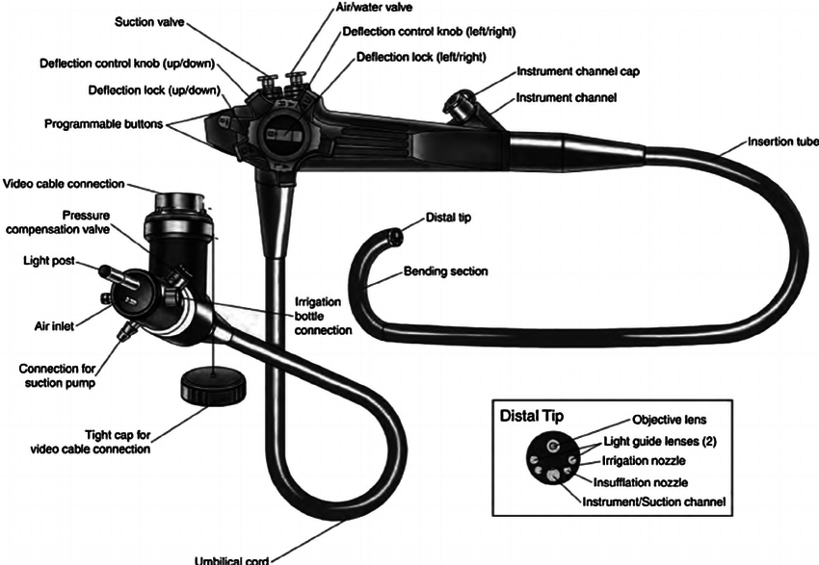

Figure 3 Various parts and controls on a flexible endoscope.

**Distal end:**The distal end is inserted into the patient's body and can be bent in the desired direction with the help of controls on the viewing end. The image is captured and focused by a lens on the end.

**Connection cable:** This 1.5 m cable length provides connection between the endoscope and the light source. In addition, the insertion tube contains angulation control wires that produce large bending angles that are required for visualization of tissue from different sides. The angulations are provided by a strong set of guide wires that allows the distal end to be deflected towards four directions: up, down, left, and right. The wires control is provided at the proximal end and allows control of the viewing angle at the distal end.

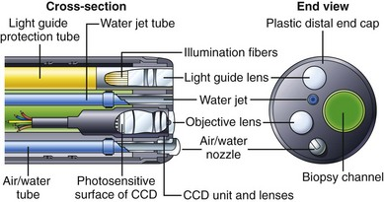

Figure 4 Constructional details of a rigid endoscope.

Figure 5 illustrates a block diagram of an endoscope. It has various components in the image capture and display chain, which include generating light, capturing an image, signal conditioning, and image processing. The light source is an LED that supplies a bright light with controlled directionality. The LEDs can be selected and optimized to match the spectral requirements of the application. The illumination level and timing of an LED can be precisely controlled by a pulse width modulator (PWM). The image is captured by a miniaturized charge-coupled device (CCD) sensor located directly behind the objective lens that detects reflected light and converts the light to an analog electrical signal. The surface of the CCD is divided into a two-dimensional array of pixels, which may be over a million in number. The signal is transmitted over the light tube's length using low-noise line drivers.

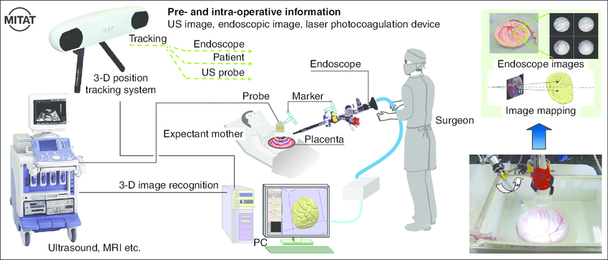

The final image quality, to a large extent, depends upon the design of the analog front end (AFE). The AFE performs signal conditioning on the analog electrical signal received from the sensor and converts image information to a digitized representation through an analog-to-digital converter.

The digital output of the AFE goes to a low-voltage differential signaling (LVDS) circuit that uses differential data transmission. The differential scheme has a significant advantage over single-ended schemes as it is less susceptible to common mode noise. LVDS is a high-speed (155.5 Mbps), low-power, general-purpose interface standard. After LVDS, the image information is processed in the image processor whose output goes to display circuits, including high-definition (HD) display.

HD endoscopy uses a CCD detector with a much higher number of pixels (greater than a million) than conventional endoscopes (pixel number from 0.1 to 0.3 million) to increase resolution by about 10 times. Similarly, high-magnification endoscopes have been introduced, which use optical zoom technology to better visualize the object surface and identify the abnormalities. The image magnification is achieved by using a movable, motor-driven lens in the optical train. The zoomed magnification achieved is 170 as compared with 35 in standard instruments.

The use of endoscopes is minimally invasive, as only a small incision is made in the body, whereas open surgery requires much deeper incisions. After endoscopy, recovery is much quicker as there is less swelling, scarring, and risk of infection. In most of the cases, endoscopy can be performed as an outpatient procedure and may not require a hospital stay. Specialized endoscopes are named depending upon their area of application.

For example, cystoscope (bladder), nephroscope (kidney), bronchoscope (bronchi/lungs), laryngoscope (larynx + the box), otoscope (ear), arthroscope (joint), laparoscope (abdomen), colonoscopy (colon), enteroscopy (small intestines), hysteroscopy (uterus), ureteroscopy (ureter), and gastrointestinal endoscopes. Endoscopes with forceps (tongs) and scissors can be used to operate or remove tissue for biopsy. The endoscope is inserted through an incision or opening in the body that leads to the area under investigation. Biopsy forceps are then used to take a sample of tissue that can then be analyzed by a pathologist.

**Fiber optic instruments**

**Characteristics:**

 Based on optical viewing bundles 2-3 mm in diameter and contains 20,000-40,000 fine glass fibers, each close to 10 um in diameter . Each individual glass fiber is coated with glass of a lower optical density to prevent leakage of light from within the fiber. The space between the fibers causes a dark 'packing fraction so fine mesh frequently apparent in the fiberoptic image

**Advantages:**

Fiber optic bundles are extremely flexible, and an image can be transmitted even when tied in a knot.

Small diameter

Direct view (monitor not necessary)

**Limitations:**

The image of a fiber optic bundle 10 quality of bundle, though excellent, can never equal that of a rigid lens system or a video endoscope.

Limited number of "pixels"