**Nervous System**

The nervous system is remarkable for its ability to process vast amounts of information and control complex bodily functions. Every minute, it receives millions of bits of data from sensory nerves and organs, integrating this information to determine appropriate responses.

**General Design of the Nervous System**

The nervous system can store experiences in the brain for varying durations, influencing bodily reactions at a later time. The somatic portion of the sensory system, transmits sensory information from the body's surface and deep structures to the central nervous system via peripheral nerves. This information is processed in multiple sensory areas, including the spinal cord, the reticular substance of the brainstem (medulla, pons, and mesencephalon), the cerebellum, the thalamus, and areas of the cerebral cortex.

**Nervous System Neuron: The Basic Functional Unit**

The central nervous system contains over 100 billion neurons. A typical neuron, such as those found in the brain's motor cortex, receives incoming signals through synapses located on dendrites and the cell body. These synapses can number from a few hundred to as many as 200,000, depending on the neuron type. The output signal travels via a single axon, which may branch to various parts of the nervous system or peripheral body.

**Sensory Part of the Nervous System—Sensory Receptors**

Most nervous system activities begin with sensory experiences that stimulate sensory receptors, such as visual receptors in the eyes, auditory receptors in the ears, or tactile receptors on the body's surface. These experiences can trigger immediate reactions or form memories that influence future responses.

**Motor Part of the Nervous System—Effectors**

The primary role of the nervous system is to control bodily activities by managing:

Skeletal Muscle Contraction: Throughout the body.

Smooth Muscle Contraction: In internal organs.

Secretion of Chemical Substances: By exocrine and endocrine glands.

These activities are known as motor functions, and the muscles and glands involved are called effectors because they execute the functions dictated by nerve signals.

Skeletal muscles can be controlled from multiple levels of the central nervous system, including the spinal cord, the reticular substance of the brainstem, the basal ganglia, the cerebellum, and the motor cortex. Each area plays a specific role, with lower regions handling automatic responses and higher regions managing deliberate, complex movements controlled by thought processes.

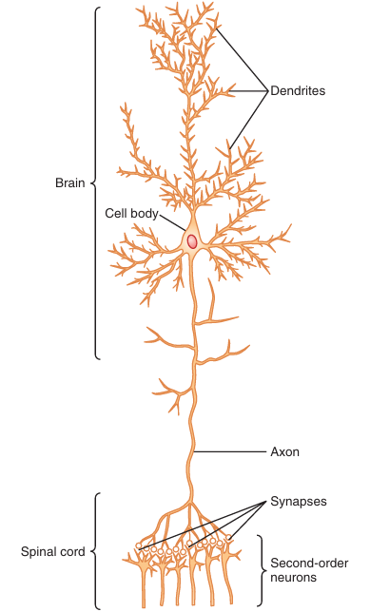 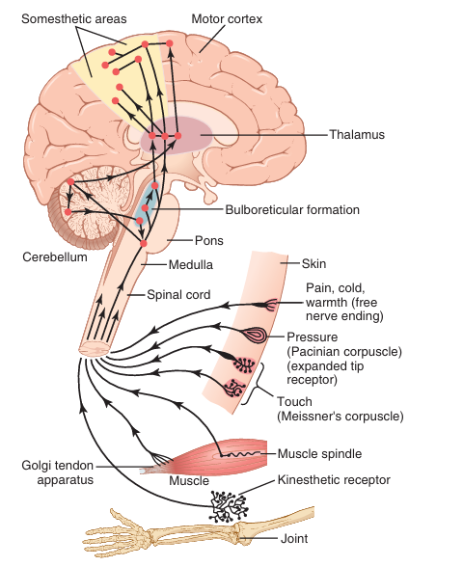

**Processing of Information: The "Integrative" Function of the Nervous System**

The nervous system plays a crucial role in processing incoming information to elicit appropriate mental and motor responses. Over 99% of sensory information is filtered out by the brain as irrelevant, such as the sensation of clothing on the body or seat pressure while sitting. Similarly, only select objects in our field of vision capture our attention, and background noise is typically relegated to the subconscious.

However, when significant sensory information stimulates the mind, it is promptly directed to the appropriate integrative and motor regions of the brain to initiate desired responses. This process of directing and processing information is known as the integrative function of the nervous system. For example, if someone places their hand on a hot stove, the immediate response is to lift the hand. Additional responses may include moving the entire body away from the stove and possibly shouting in pain. This integrative function ensures that the body reacts appropriately to important stimuli.

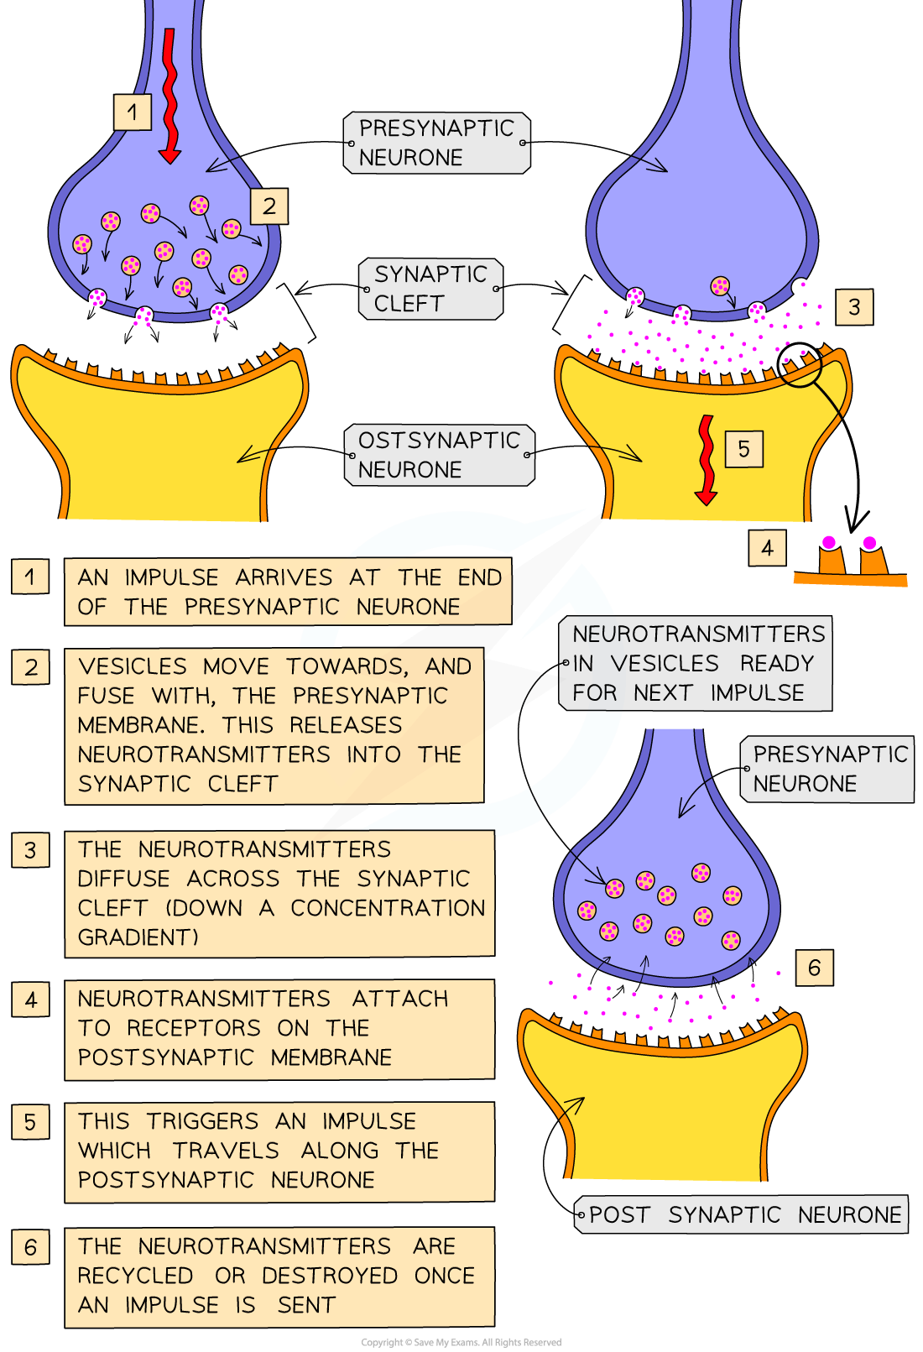

**Role of Synapses in Processing Information**

Synapses serve as the critical junctions between neurons, facilitating the transmission of signals from one neuron to the next. These junctions play a pivotal role in directing the flow of nervous signals throughout the nervous system. The efficiency with which synapses transmit signals can vary significantly; some synapses allow signals to pass with ease, while others may transmit them with difficulty.

**Control of Synaptic Transmission**

Synaptic transmission is subject to control by facilitatory and inhibitory signals from other parts of the nervous system. These signals can either enhance or suppress the transmission of signals across synapses, effectively opening or closing them to information flow. This regulatory mechanism allows the nervous system to selectively process information, prioritizing strong signals over weak ones.

**Levels of the Central Nervous System**

The human nervous system has inherited functional capabilities from each stage of evolutionary development, leading to three major levels of the central nervous system with distinct characteristics:

**Spinal Cord Level**: Often viewed as merely a conduit for signals between the body and brain, the spinal cord is capable of highly organized functions even after being severed in the high neck region. It can control walking movements, reflexes to withdraw from pain, reflexes to stiffen legs against gravity, and reflexes controlling local blood vessels, gastrointestinal movements, or urinary excretion. The upper nervous system often operates by sending signals to spinal cord control centers rather than directly to the body.

**Lower Brain or Subcortical Level**: Many subconscious body activities are controlled in the lower brain areas, including the medulla, pons, mesencephalon, hypothalamus, thalamus, cerebellum, and basal ganglia. For example, arterial pressure and respiration are primarily controlled in the medulla and pons. Equilibrium is managed by the older parts of the cerebellum and the reticular substance of the medulla, pons, and mesencephalon. Feeding reflexes, such as salivation and lip licking in response to food taste, are controlled by areas in the medulla, pons, mesencephalon, amygdala, and hypothalamus. Additionally, emotional patterns like anger, excitement, sexual response, pain reaction, and pleasure reaction can occur even after significant damage to the cerebral cortex.

**Higher Brain or Cortical Level**: This level is primarily responsible for higher cognitive functions, including complex thought processes and memory storage. It integrates sensory information and controls voluntary motor activities. The cerebral cortex plays a crucial role in facilitating complex behaviors and cognitive processes.

References:

Hall, J. E. (2016). Guyton and Hall textbook of medical physiology (13th edition)

<https://www.brainfacts.org/brain-anatomy-and-function/cells-and-circuits/2022/synapses-and-neurotransmission-113022>

<https://byjus.com/neet/short-notes-of-biology-for-neet-synapse/>

<https://en.wikipedia.org/wiki/Synapse>