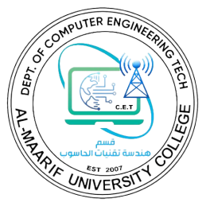Ministry of Higher Education

Al-Maarif University College

Computer Engineering Techniques Department

**Final Exam 2021-2022**

|  |  |  |
| --- | --- | --- |
| Subject: | **Digital communication** | Time: **3 hours** |
| Branch:Both |  | Level: Third |

**Note: Attempt Five Questions Only:**

**Q1\ Draw a block diagram of a digital communication system, obtain mean function of each element.**

**Q2\ What is difference between uniform and Non-uniform quantization.**

**Q3\ Explain in brief a digital coding.**

**Q4\ Find the correct choice:**

**1-the communications medium causes the signal to be:**

1. **Amplified.**
2. **Attenuated.**
3. **Modulated.**
4. **Interfered with.**

**2-the process of transmitting two or more information signals simultaneously over the same channel is called**

1. **Multiplexing**
2. **Telemetry**
3. **Detection**
4. **Modulation**

**3-recovering information from a carrier is known as**

1. **Demultiplexing**
2. **Detection**
3. **Carrier recovery**
4. **Modulation**

**4-radio signals are made up of**

1. **Voltages and currents**
2. **Electric and magnetic fields**
3. **Electrons and protons**
4. **Noise and data**

**Q5\ Determine whether the following signals are periodic or not:**

1. **X(t) = cos 7πt**
2. **X(t) = cos 3πt**

**Q6\The information in an analog signal voltage is to be transmitted a bandwidth of 200Hz and an amplitude range of -5 to +5 volts.**

1. **Find the minimum sampling rate required.**
2. **Find number of bits in each PCM word.**
3. **Find minimum bit rate required in the PCM signal.**
4. **Find the minimum absolute channel bandwidth required for the transmission of the PCM signal.**