



**Medical parasitology**

**Lecture Seven**

**Ciliophora (Balantidium coli)**

**By**

**Dheyauldeen Aftan Hamad Al-Hayani**

**B. Sc. M. Sc. Microbiologist**

**Subphylum : Ciliophora**

***Balantidium coli***

**Geographical Distribution: Worldwide.**

**Habitat:** Largest protozoal parasite inhabiting large intestine of man.

Also found in pigs and monkeys.

**Morphology**

**Trophozoite**

1. Oval 50 to 200 µ × 40 to 70 µ, Surface is pointed with delicate cilia.
2. Anterior endpointed and has cytostome.
3. Posterior end is round.
4. Cytoplasm contains kidney-shaped large macronucleus and small micronucleus.

**Cyst**

Oval, Thick, outer wall Cilia absent. Enclosed in a double-layered wall.

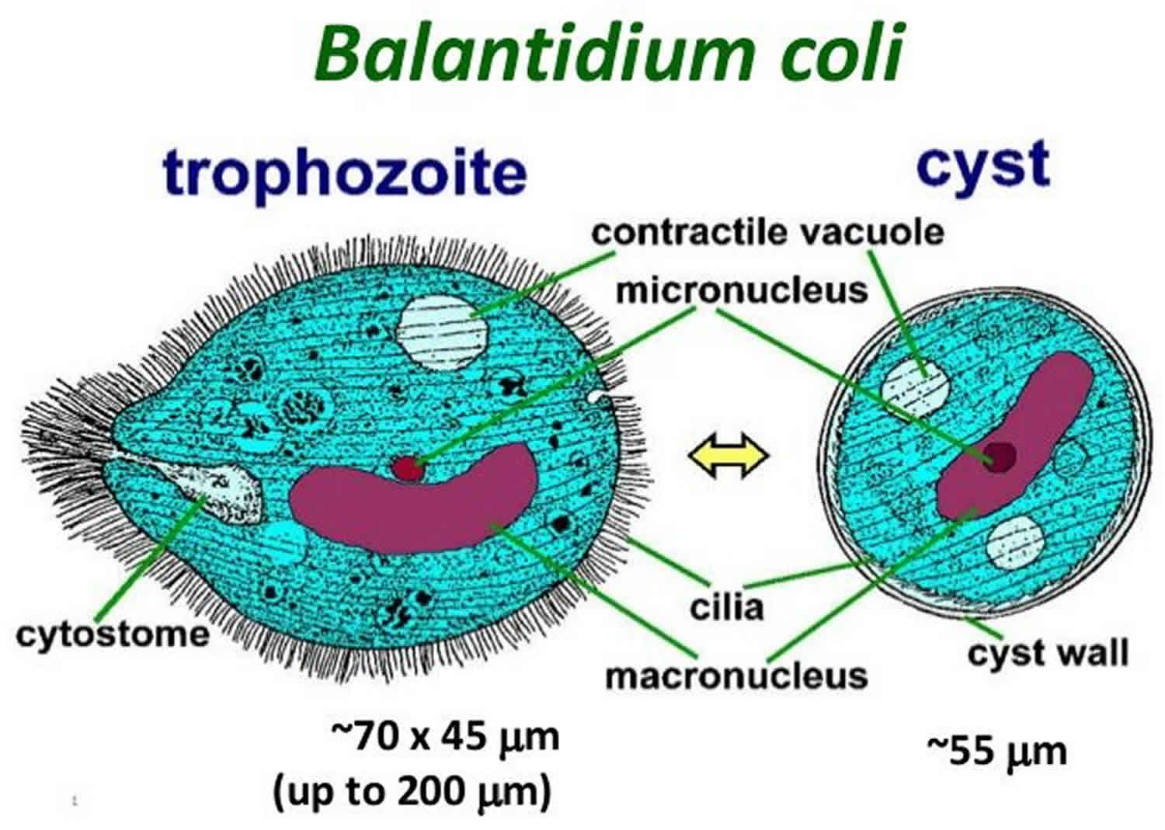

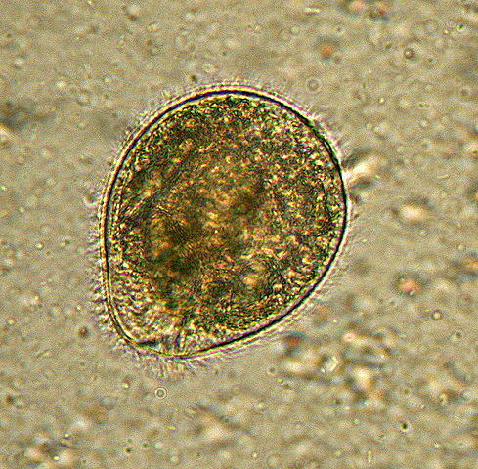

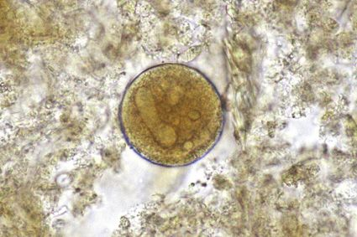

**Life cycle**

1. No intermediate host is required.
2. The cysts are passed in the stool.
3. Infection occurs by ingestion of cysts with contaminated food or drinks.
4. In the wall of intestine excystation occurs and trophozoites develop which live and subsequently multiply by binary fission on the mucosa of large intestine.

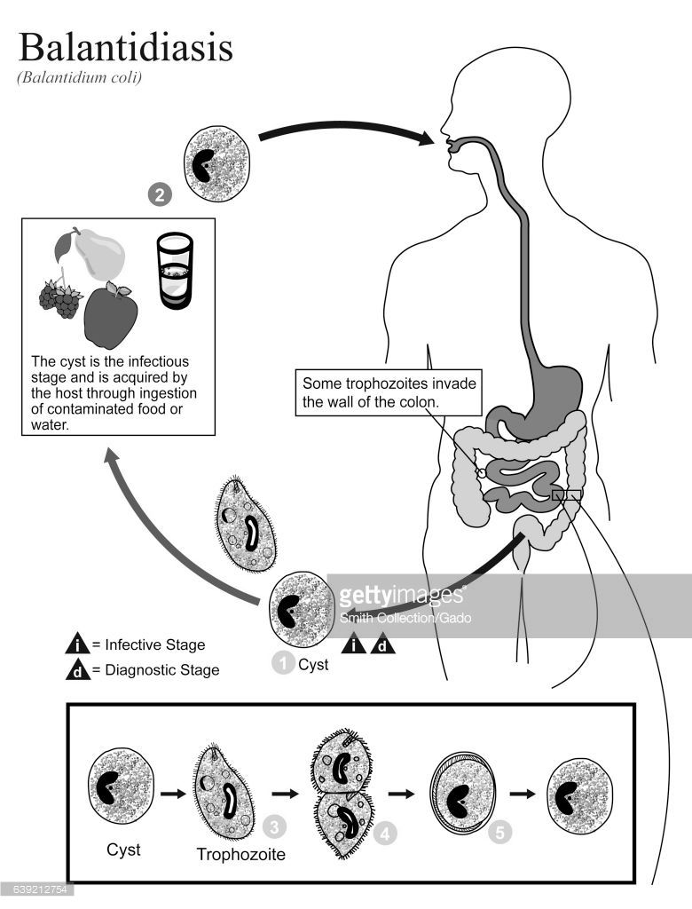

**Transmission**

*Balantidium* is the only ciliated protozoan known to infect humans. Balantidiasis is **a zoonotic disease** and is acquired by humans via **the feco-oral route from the normal host**, the pig, where it is asymptomatic. Fecally contaminated food and water are the common sources of infection in humans.

**Pathology**

1. Rarely mucosal damage caused by trophozoites.
2. Action of **enzyme** **hyaluronidase** produced by parasite may cause **mucosal damage** by **superficial ulcer** which may penetrate to sub-mucosa, so results diarrhea and later frank dysentery develops.
3. **Abdominal colic**, **nausea**, and **vomiting** may occur.

**Symptoms and signs**

Usually asymptomatic in immunocompetent individuals, but the symptoms of balantidiasis include:[citation needed]

Intermittent diarrhea

Constipation

Vomiting

Abdominal pain

Anorexia

Weight loss

Headache

Colitis

Marked fluid loss

The most common ones are intermittent diarrhea and constipation or inflammation of the colon combined with abdominal cramps and bloody stools.

**Laboratory Diagnosis**

The diagnosis of balantidiasis can be considered when a patient has diarrhea combined with a probable history of current exposure to **pigs** (as pigs are the primary reservoir), contact with infected persons, or anal sexual contact.

1. The diagnosis of **balantidiasis** can be made by **microscopic examination of stools** in search of [trophozoites](https://en.wikipedia.org/wiki/Trophozoites" \o "Trophozoites) or cysts,
2. **Colonoscopy or sigmoidoscopy** to obtain a [biopsy](https://en.wikipedia.org/wiki/Biopsy) specimen from the large intestine, which may provide evidence for the presence of [trophozoites](https://en.wikipedia.org/wiki/Trophozoites" \o "Trophozoites).

**Prevention**

*Balantidium coli* infection can be prevented when traveling by following good hygiene practices.

1. Wash your hands with soap and warm water after using the toilet
2. changing diapers
3. before handling food.

4. Purification of drinking water.

**5**.Proper handling of food.

**6**.Careful disposal of human feces.

**7**.Monitoring the contacts of balantidiasis patients

**Treatment**: **Tetracycline, metronidazole, and iodoquinol**.