## University of Baghdad College of Nursing

**Community Health Nursing Department Leadership and Management in Nursing**

## المحاضرة الرابعة

## Pyramid Skills Management

Developing as a manager requires ongoing, personal commitment to mastering new skills and behaviors. The Management Skills Pyramid offers some guidance on where, when, and how one goes about developing into a successful manager.

# The Management Skills Pyramid

The management skill pyramid is adopted to show the increasing skills a manager must master during the role of management. The Pyramid's structure in the figure below, it gives a snapshot of how these skills work together. Understanding how these management skills build on each other will help achieve success in [management career](https://www.thebalancecareers.com/management-career-paths-2275866).

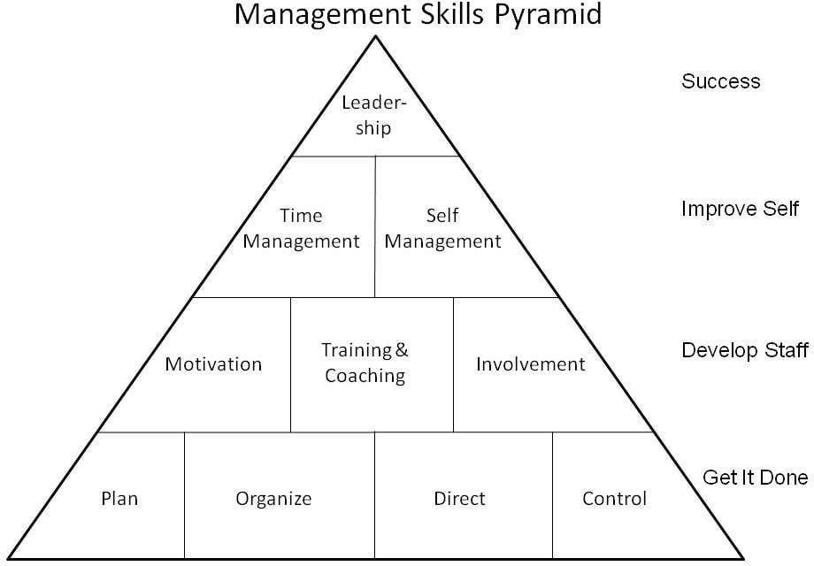

# Management Skills Pyramid, Level 1

Level 1 of the Management Skills Pyramid shows the basic skills a manager must master to ensure the work of the organization is completed at the right pace, quality, and cost. These are the [fundamentals of the management job](https://www.thebalancecareers.com/getting-a-first-management-job-2275109):

* **Plan:** This is the first and most important step in any management task and one of the powerful factors to increase productivity and achieve the desired results. Planning in advance makes more efficient and effective work processes and prevents poor performance and exposure to risk. It includes determination of resource needs and necessary investments; schedule activities and work teams and plan for future needs.
* **Organize:** A professional manager must be able to organize employees, work tasks, and projects and even must be able to organize himself, the time, and effort to be most effective in order to maintain the workflow, get the team’s tasks done and gain results in the most efficient and effective manner in the face of constant changes in resources, goals, and external factors. Clearly, there is a lot of confusion between planning the work and organizing it. Where planning focuses on what needs to be done, the organization is more operational and is more focused on how to get the work done best.
* **Direct:** This is the action step and implementation. the manager is responsible to sensitize employees about their individual roles in achieving the goal and directing them to complete the work and to ensure that he covers what they need to carry out their tasks and has strategies to motivate them and solve their problems. Provide daily guidance to ensure performance in alignment with company standards.
* **Control:** The manager must monitor and control the team’s activities, work tools, and resources, check if the actual work progress matching the same way and deadlines that were set before in the planning stage. Also, he’ll have to step in to assist the team and handle the problems when the environment changes and crisis times. Monitor, track, and report on output, efficiency, cost, and quality.

# Management Skills Pyramid, Level 2

Moving beyond the supervisory and basic management tasks, Level 2 challenges to cultivate and strengthen people management skills. These are frequently referenced as "[soft skills](https://www.thebalancecareers.com/why-soft-skills-are-important-for-managers-4158692)" in management and leadership literature and encapsulate Level 2 in the Management Skills Pyramid. These skills will be used to motivate and develop the staff.

There are [many specific skills](https://www.thebalancecareers.com/what-are-job-specific-skills-2063755) required, but they are grouped into these categories:

* **Motivation:** The most important skills to manage a team as a manager is the ability to motivate the team encourage individuals to work, achieve tasks, and improve their performance to reach the results he is waiting for. Motivate each member of the team requires recognition from the manager that the abilities and needs of each individual and team member are different and it requires a different approach. Creating an environment that encourages people to engage and deliver their best efforts.
* **Training:** Coaching is a process needs it to be able to identify the knowledge level, training needs of your team members and the roadblocks that prevent them from moving forward in the work and be able to offer them the good training program, to help them achieve their best levels of performance. Managers who utilize coaching to develop their staff help employees feel empowered to face new challenges and work pressures.

There are five general phases of coaching: connect, focus, discover, act, and evaluate. **.**Ensuring that the team members have the fundamental skills and knowledge they need to execute the tasks of your department.

* **Coaching:** Helping the team members discover how to improve performance and behaviors in support of higher individual and group achievement.
* **Employee involvement:** in order to be able to manage work with less hassle, first have to empower the staff to make decisions, invent solutions, and take responsibility for their work outcomes.

There are three factors that need to be in order for increasing employee involvement and empowerment to work. As a manager, first, you must set a process of free-flowing information. Second, the need to share the responsibility for the work outcomes. Finally, create mutual respect with your team members. Encouraging collaboration for problem-solving and innovation in the pursuit of daily work tasks.

# Management Skills Pyramid, Level 3

As strengthen the manager abilities at the lower levels of the Pyramid, self- development becomes increasingly important. Level 3 management

skills include:

* **Self-management:** management of the self by oneself and it is the hardest level of skills because it is the responsibility for one’s own behavior and well-being. Knowing the abilities, what can actually be done and what the lacks in him to cover and develop it, handle his effort and ability to work under stress, external and personal factors that may affect him. Achieve appearance and personality commensurate with the position as a manager. Motivating and engaging with others, while navigating the challenges of daily work and management life.
* **Time management:** the manager must be a multi-tasking person. So this skill is essential to organize and plan how to divide time between specific activities and increase productivity and efficiency. Good time management enables to work smarter, not harder to get more done tasks in less time, even when the time is tight and pressures are high. Knowing how and where to invest time throughout the day.

[Time management](https://www.thebalancecareers.com/time-management-skills-2063776) is often considered primary within Level 3. Taking control of schedule ensures to understand that time is most precious resource. High-level managers know that they can invest their time or squander it. Therefore, they guard their time and consider it as important as financial resources.

# Management Skills Pyramid, Top Level

This level is the highest stage in the management skills levels pyramid. It is indicative of that more important than being a manager who only oversees the work and performance of traditional managerial tasks are manager roles as a leader, inspiring and role model for employees to succeed and to have an effective, significant and influential role in the work environment and make a difference in the surroundings. The manager will know that he become a leader when create something new in the work diary, change complex and routines, or overcome the problems and obstacles you face with innovative solutions and have followers who trust your decisions and believe in your vision.

# Management Skills Development and the Pyramid

While the Pyramid illustrates the [skill sets](https://www.thebalancecareers.com/what-is-a-skill-set-2062103) of managers, in reality, individuals often inhabit multiple levels at the same time. All management jobs require elements in each level outlined in the Pyramid.

What Is a Skill Set?

A skill set is the knowledge, abilities, and experience needed to perform a job. Specific skill set areas can include human relations, research and planning, accounting, leadership, management, and computer skills.

A skill set is the combination of knowledge, personal qualities, and abilities that has been developed through life experience and work. It typically combines two types of skills: soft skills and hard skills.

[**Soft skills**](https://www.thebalancecareers.com/what-are-soft-skills-2060852) **a**re interpersonal or people skills. They are somewhat difficult to quantify and relate to someone's personality and ability to work with others. This in-demand skill set includes good communication, listening, attention to detail, critical thinking, empathy, and conflict resolution abilities, among other skills.

[**Hard skills**](https://www.thebalancecareers.com/what-are-hard-skills-2060829) are quantifiable and teachable. They include the specific technical knowledge and abilities required for a job. Examples of hard skills include computer programming, accounting, mathematics, and data analysis.

**Skill Sets for Health Careers (Example)**

Nurses and other healthcare professionals need several skill sets to succeed. They must be able to perform certain procedures (such as giving vaccinations and drawing blood), be tech-savvy, and use soft skills to connect with patients and colleagues. Essential skills for health care professionals include:

Not import net

* Adaptability
* Analysis
* Applying current research to medical practice
* Attention to detail
* Collaboration
* Diagnosis
* Care plan development
* Leadership
* Active listening
* Math
* Multitasking
* Organization
* Problem-solving
* Understanding and applying rules and regulations
* Research
* Time management