Microbiology

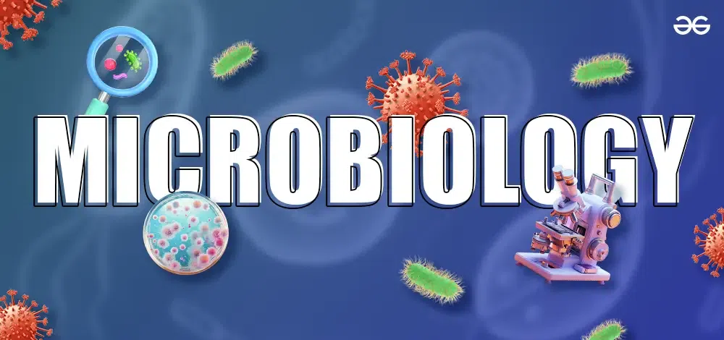

Microbiology

**Lecture 1**

**Morphology & Ultra-Structure of Microorganism**

**MSc O.M.**

**Dr. Shaden H. Alaloosi**

## References

1. **Essential Microbiology for Dentistry**

by Lakshman Samaranayake

1. **Microbiology and Immunology**

by Richard Hunt

# Microbiology

* + **Microbiology:** is a great complex of biological sciences about microorganisms, it studies organisms too small to be seen without magnification.
* **Micro** - too small to be seen with the naked eye
* **Bio** - life
* **logy** - study of
  + **Microorganisms are ubiquitous, include:**
    - bacteria
    - viruses
    - fungi
    - Parasite {protozoa & helminthes (worms)}
    - algae

### History of the Study of Microorganisms

#### Robert Hooke (1665)

1. little boxes or cells
2. Cell Theory

The cell theory states that:

* + All living things are made of one or more cells.
  + Cells are the basic unit of structure and function in living things.
  + All cells come from other cells.

#### van Leeuwenhoek (1674)

* He was the first to actually see living microorganisms and named their as “animalcules”
* He constructed first microscope with magnification about 50 to

300 times

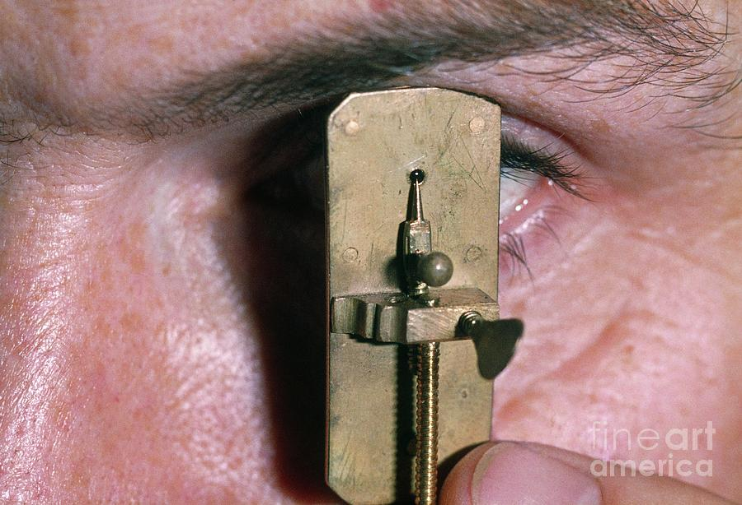

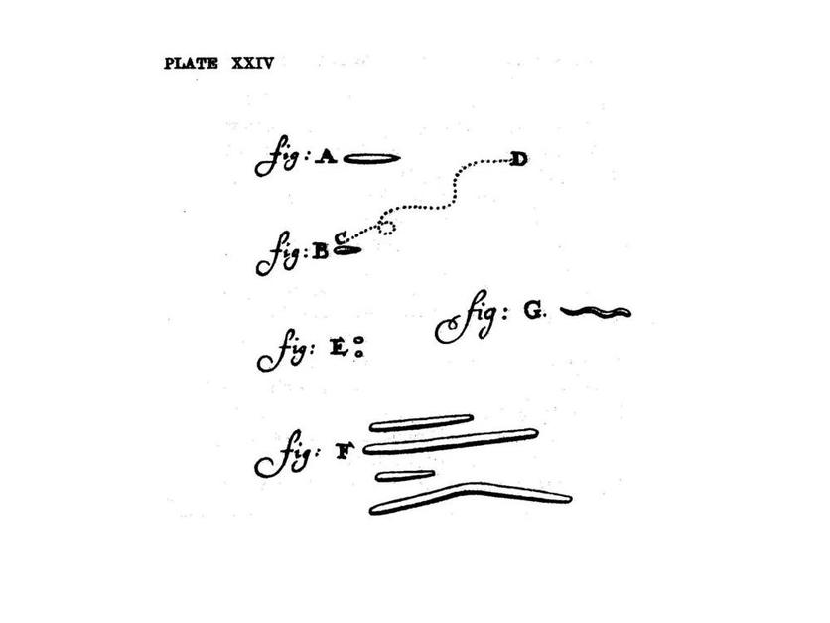

#### Louis Pasteur (1822)

* Established fermentation : was the result of microbial activity
* Introduced techniques of sterilization
* Showed that microorganisms do not arise by spontaneous generation.
* Elaborated methods of pathogenic micro-organisms attenuation
* Developed rabies vaccine.
* **Robert Koch (1843)**
* Elaborated methods of staining and cultivation of microorganisms.
* Discovered causative agents of anthrax, cholera and tubercle bacillus.
* Elaborated criteria for proving relationship between a microorganism and a specific diseases **(Koch's postulates).**

1. The microorganism must be present in every case of the disease but absent in healthy

organism.

1. The suspected microorganism must be isolated and grown in a pure culture.
2. The same disease must result when the isolated microorganism is inoculated into a healthy host.
3. The same microorganism must be isolated again from the diseased host.

Cell Types

* Based on the organization of their cellular structures, all living cells can be divided into two categories:

**Eukaryotic Cells**

Cell that have membrane-bound organelles

Animals, plants, fungi, protozoa, and algae

**prokaryotic cells**

Cells that **do not** have membrane-bound organelles

Unicellular organisms such as **bacteria and blue**

**green algae**



* **All cells are surrounded by a *plasma membrane*.**



**Similarities**

•



**The semi-fluid substance within the cell is called “cytosol”,**



**containing the cell organelles.**

•



**All cells contain chromosomes which have genes in the form of**



**DNA.**

•



**All cells have tiny organelles called “*Ribosomes”* that make**



**proteins.**

#### A major difference between prokaryotic and eukaryotic cells is the location of chromosomes.

1. **In an eukaryotic cell, chromosomes are contained in a membrane-enclosed organelle, the *nucleus*.**

#### In a prokaryotic cell, the DNA is concentrated in the nucleoid without a membrane separating it from the rest of the cell.

1. **Prokaryotic Cells** much smaller (microns) and more simple than eukaryotes aod this large surface-to-volume ratio enable in prokaryotes nutrients easily and rapidly reach any part of the cells.

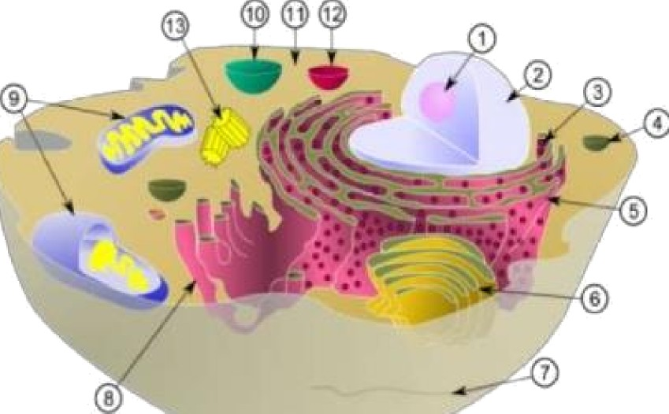

Schematic of typical animal (eukaryotic) cell, showing subcellular

components.

Organelles:

* + 1. nucleolus (2) nucleus (3) ribosome (4) vesicle (5) rough ER

(6) Golgi apparatus (7) Cytoskeleton (8) smooth ER (9) miachondria

(10) vacuole (11) cytoplasm (12) lysosome (13) centrio

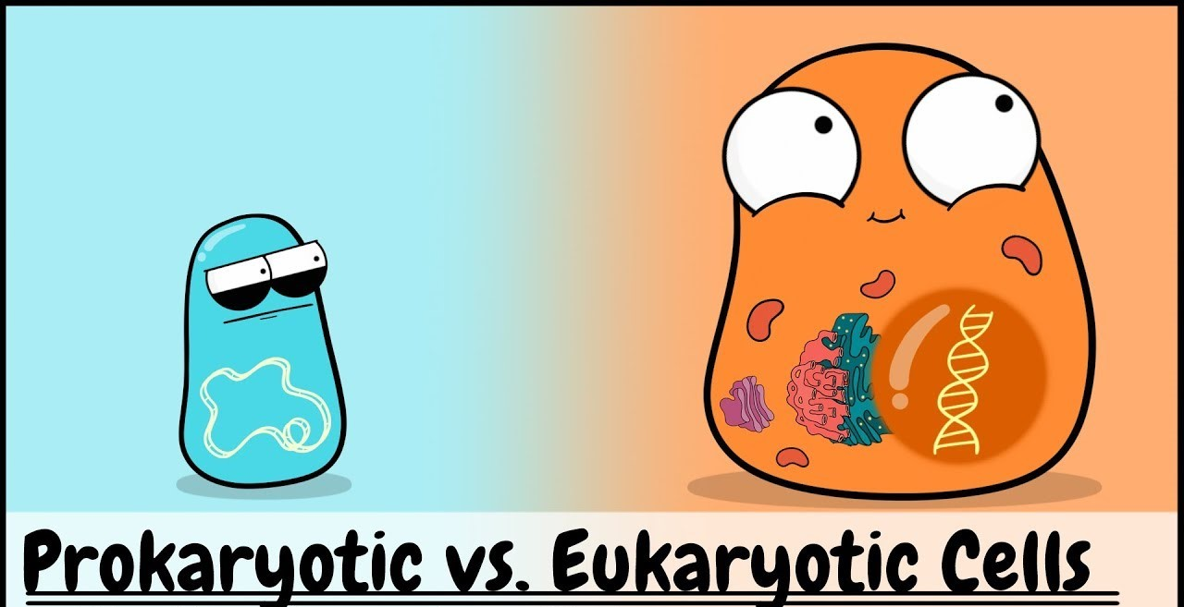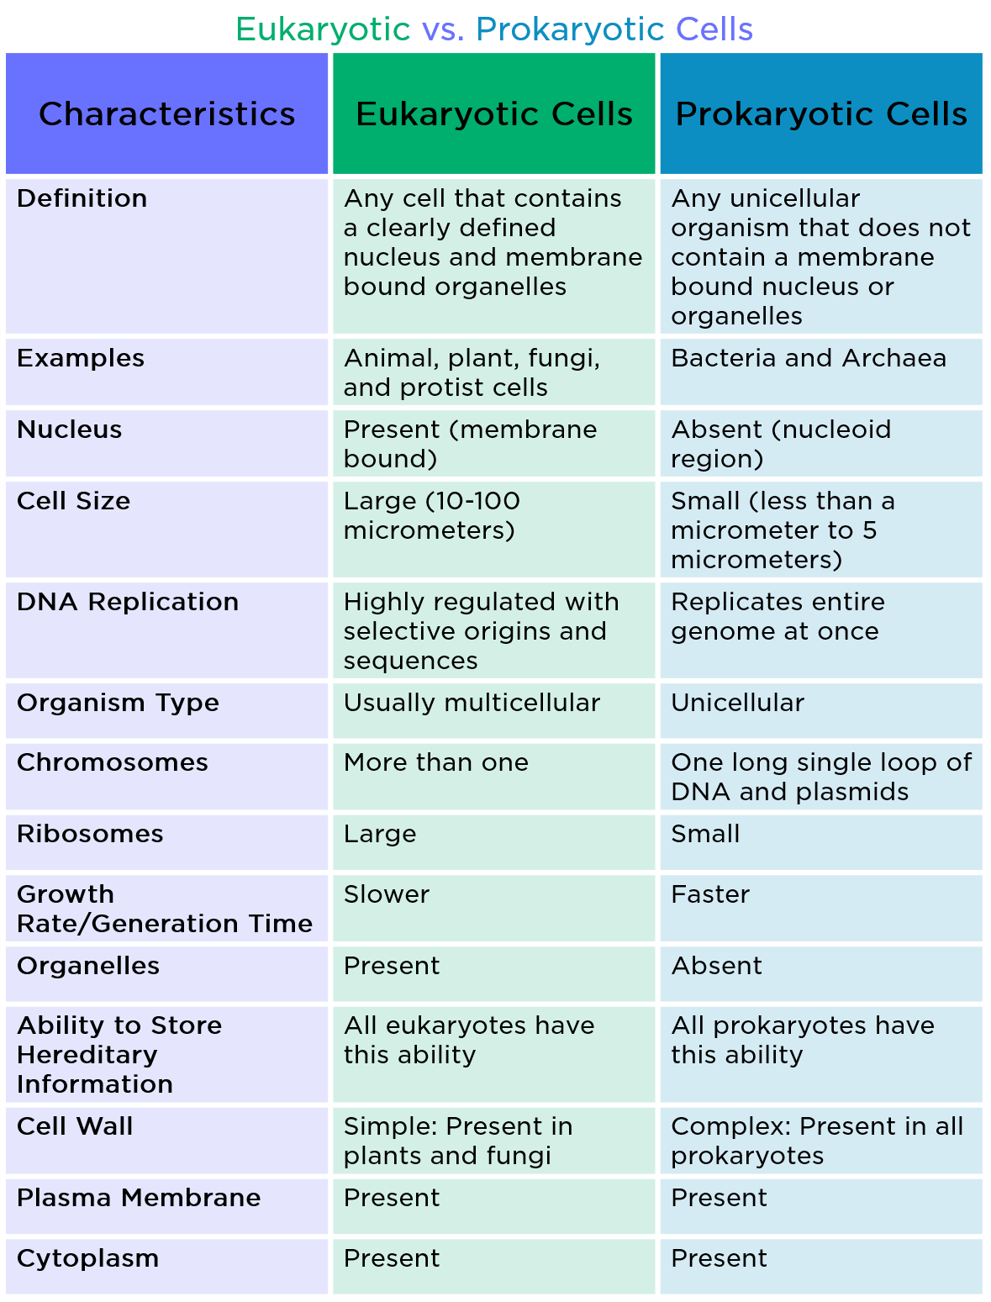Size of Bacteria

* + - Unit of measurement in bacteriology is the micron / micro-meter (µm)
    - Bacteria of medical importance
* 0.2 – 1.5 µm in diameter
* 3 – 5 µm in length

**Shape of Bacteria**

* Cocci – spherical/ oval shaped (major groups)
  + Bacilli – rod shaped
* Vibrio – comma shaped
* Spirilla – rigid spiral forms
  + Spirochetes – flexible spiral forms
  + Actinomycetes – branching filamentous bacteria

Arrangement of bacteria: Cocci

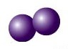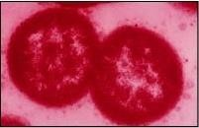Coccus

Cocci in pair – Diplococcus

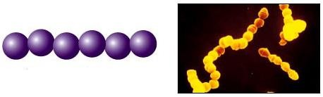

Cocci in chain - Streptococci

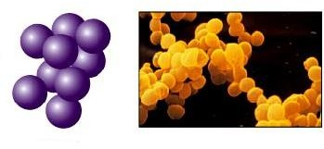Cocci in cluster - Staphylococci

Tetrad – groups of four

**Arrangement of bacteria:** Bacilli

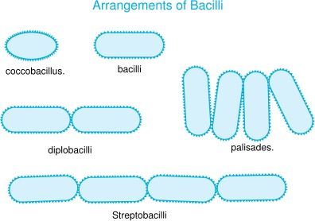

Other shapes of bacteria

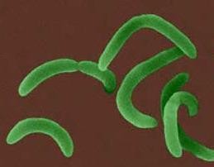

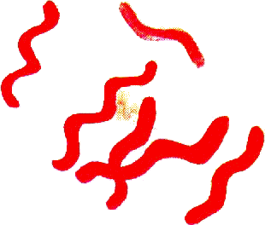

Comma shaped

Spirilla

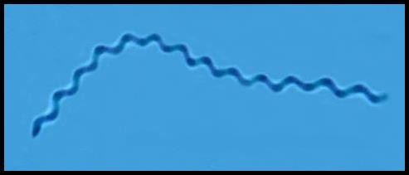

Spirochetes

Anatomy of Bacterial Cell

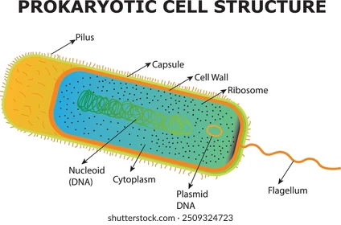

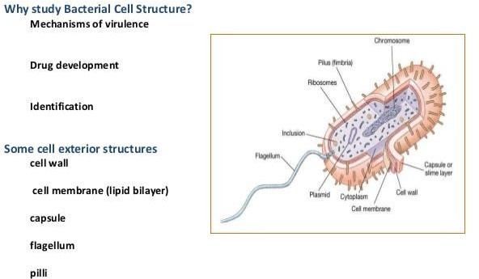

### Anatomy of Bacterial Cell

1. Outer layer - two components:
2. Rigid cell wall
3. Cell membrane or Plasma membrane
4. Cytoplasm – gel like substance contains:
   * cytoplasmic inclusions
   * ribosomes
   * mesosomes
   * nucleoid
5. Additional structures

Plasmid

slime layer

capsule

flagella , fimbriae (pili) and spores.

### Structure & Function of Cell Components

1. CELL WALL : outermost layer, surrounds cytoplasmic(plasma) membrane
2. Confers shape and rigidity
3. 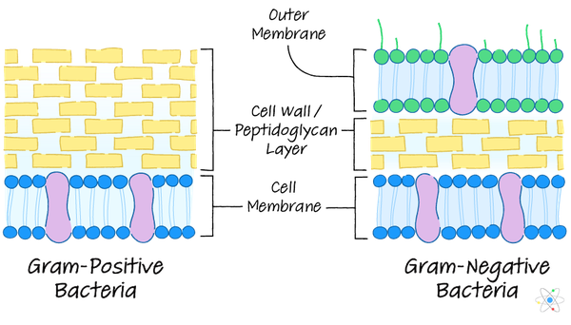Peptidoglycan is responsible for the rigidity of the bacterial cell wall and for the determination of cell shape.
4. Composed of (peptidoglycan/ murein): formed by N-acetyl glucosamine (NAG) & N-acetyl muramic acid (NAM) alternating in chains, held by peptide bonds.

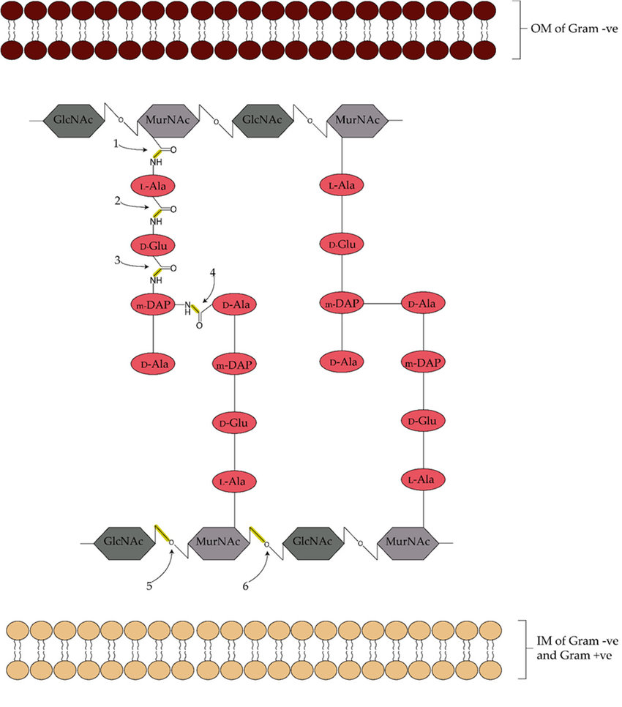

1. Can not be seen by direct light microscopy and do not stain with simple stains.
2. Carries bacterial antigens important in virulence & immunity.
3. Chemical nature of the cell wall helps to divide bacteria into two broad groups – Gram positive & Gram negative .
4. Gram +ve bacteria have simpler chemical nature than Gram –ve bacteria.
5. Several antibiotics may interfere with cell wall synthesis

e.g. Penicillin, Cephalosporins

#### Gram positive cell wall

* + The Gram-positive cell wall is composed of a **thick, multilayered peptidoglycan** sheath outside of the cytoplasmic membrane.
  + 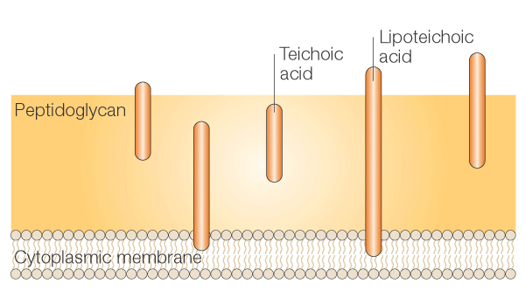 **Teichoic acids** are linked to and embedded in the peptidoglycan, and **lipoteichoic acids** extend into the cytoplasmic membrane

#### Gram negative cell wall

* The cell wall is composed of an outer membrane linked to thin single-layered peptidoglycan by lipoproteins.
* The peptidoglycan is located within the periplasmic space that is created between the outer and inner membranes.
* The outer membrane includes *porins allow the passage of small hydrophilic molecules across the membrane and **lipopoly-saccharide molecules that extend into extracellular space.

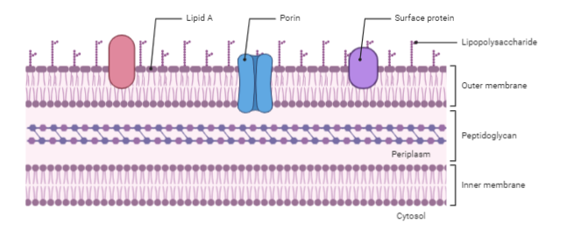

# 300px-Gram-Cell-wallCell Wall

A comparison between Gram positive and Gram negative cell wall



Peptidoglycan layer Teichoic acids Periplasmic space

LipopoTysaccharide (LPS) content

Thick (multilayered) Thin (single-layered) Present Absent

Absent present

Virtually none High

Lipid and lipoprotein content Resistance to physical disruption

Inhibition by basic dyes

Susceptibility to anionic detergents

Resistance to drying

Low Low Low

Low Low

High High High

High

High

G ram reaction

Retain crystal violet dye Can be decolorized and stain dark violet to accept counter

stain

#### Cytoplasmic (Plasma) membrane

* + Thin layer 5-10 nm, separates cell wall from cytoplasm.
  + Acts as a semi-permeable membrane controls the inflow and outflow of metabolites.
    - Composed of lipoproteins with small amounts of carbohydrates.

#### 

#### B. Cytoplasm

* Colloidal system of variety of organic & inorganic solutes in viscous watery solution

#### Cytoplasmic Components:

* + **Ribosomes=RNA**

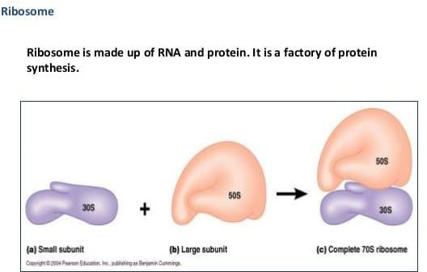

Ribosome is made up of RNA and protein. It is a factory of protein synthesis

* + **Mesosomes**
* Multi-laminated structures formed as invaginations of plasma membrane.
* Principal sites of respiratory enzymes.
* Coordinate nuclear and cytoplasmic division during **binary fission**
* More prominent in Gram +ve bacteria

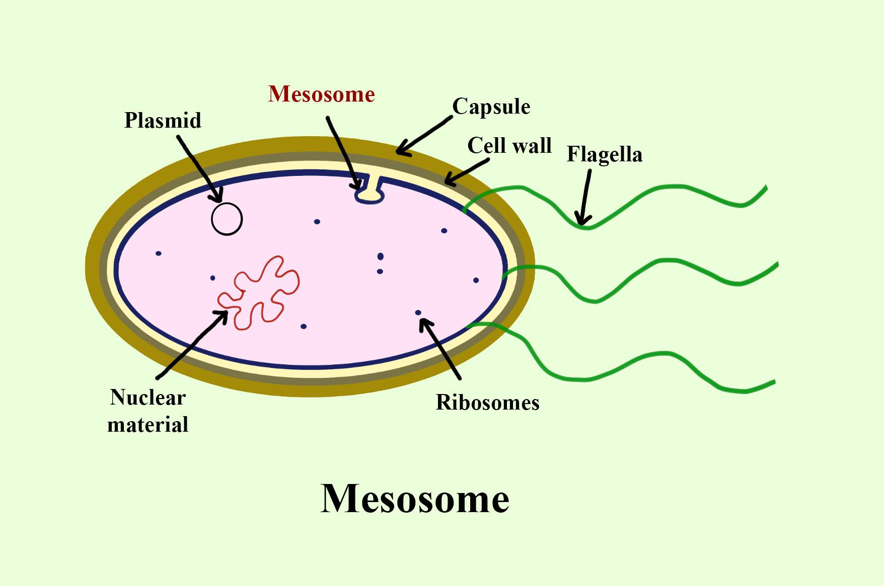

* **Intra-cytoplasmic inclusions**
  + Many species of bacteria produce cytoplasmic inclusion bodies which appears as round granules e.g. metachromatic granules in *(diphtheria bacilli).*
    - Reserve of energy and phosphate for cell metabolism and made up of either glycogen or starch.
    - They appear reddish when stained with polychrome methylene blue toluidine blue.

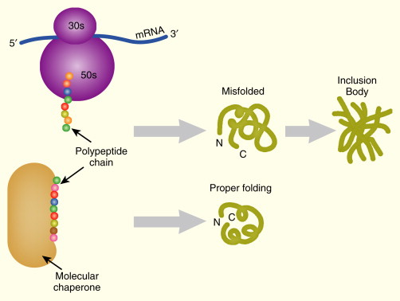

* **Nucleus**
  + - No nucleolus and no nuclear membrane.
    - Oval or elongated bodies generally 1 per cell.
    - Genome – single, circular double stranded DNA (one chromosome).
    - Divides by **binary fission**

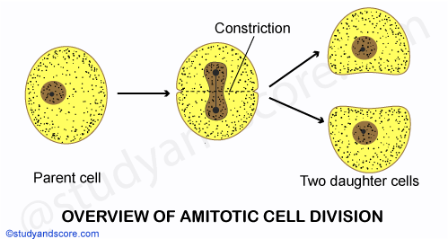

1. **Additional Organelles:**
2. **Plasmid**

* Extra-nuclear genetic elements consisting of DNA
* Transmitted to daughter cells during binary fission
* May be transferred from one bacterium to another by conjugation
* Not essential for life of the cell
* Confer certain properties e.g. drug resistance because the plasmid carries some genes responsible for drug resistance .

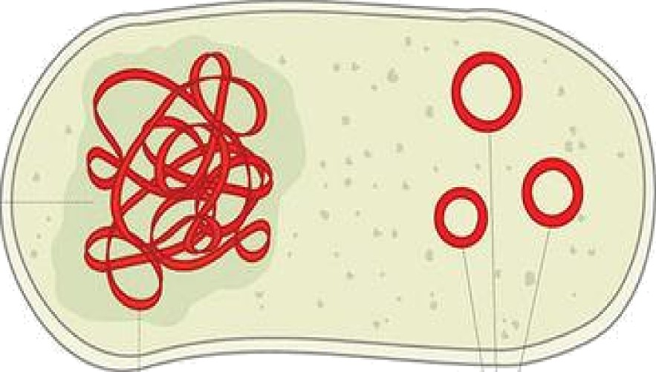Nucleokl



* Viscous layer secreted around the cell wall Polysaccharide / polypeptide in nature

1. **Capsule**

* sharply defined structure, antigenic in nature
  + Protects bacteria from lytic enzymes
* Inhibits phagocytosis
* Stained by negative staining using India Ink
* Can be demonstrated by Quellung reaction (capsule swelling reaction)

3.Slime layer – is loosely associated with the bacterium and can be easily washed off, whereas a capsule is attached tightly to the bacterium and has definite boundaries

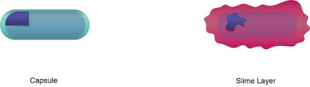

**4.Flagella**

* Long filamentous surface appendages
* Organs of locomotion
  + Composed of proteins called flagellins
* The number and distribution of flagella on the bacterial surface are characteristic for a given species - hence are useful in identifying and classifying bacteria
  + Flagella may serve as antigenic determinants (e.g. the H antigens of flagella in Gram-negative enteric bacteria)
* Presence shown by motility e.g. hanging drop preparation test.

**Each flagellum consists of 3 parts:**

1. Filament
2. Hook
3. Basal body

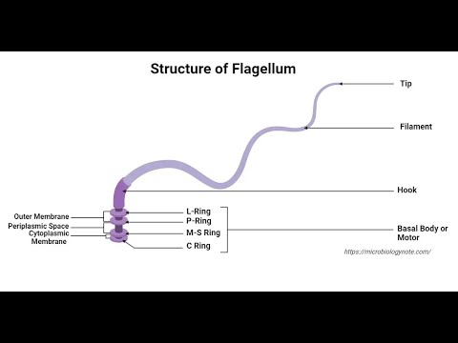

Types of flagellar arrangement

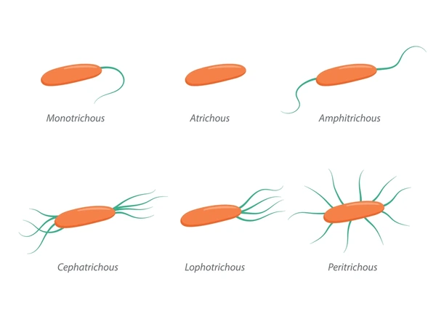

**4.Fimbriae/ Pili**

* Thin, hair like appendages on the surface of many Gram negative bacteria
* Acts as organs of adhesion (attachment) - allowing bacteria to colonize environmental surfaces or cells and resist flushing
  + Made up of proteins called pilins.
* Pili can be of two types
  1. Common pili - short and abundant
  2. Sex pili - very long pili and small number (one to six), helps in conjugation (process of transfer of DNA)

**5.Spores :**

* Highly resistant resting stages formed during adverse environment (depletion of nutrients).
  + Formed inside the parent cell, hence called Endospores
  + Very resistant to heat, radiation and drying and can remain dormant for hundreds of years.
  + Formed by bacteria like ***Clostridium*** and ***Bacillus***

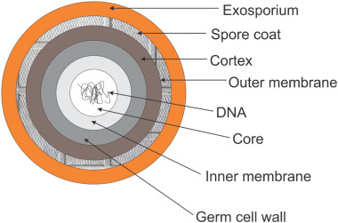

**Shape & position of bacterial spore**

Oval central

Spherical central Oval sub terminal Oval sub terminal

Oval terminal

Spherical terminal

Free spore

Non-

bulging

Bulging

Œ Bacterial spores undergoes two types of formation —

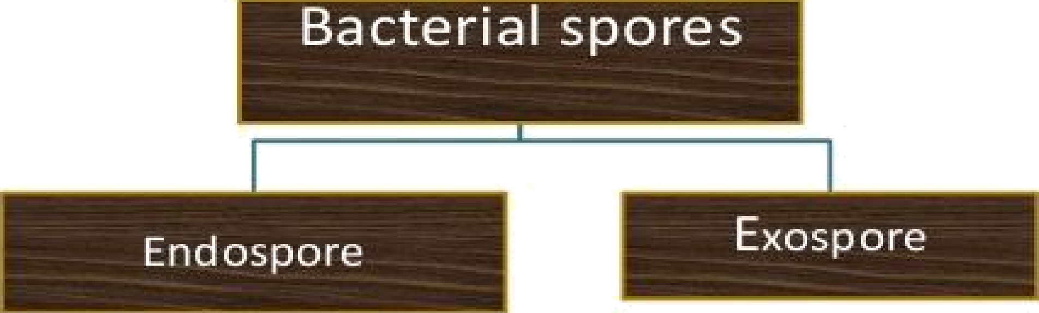

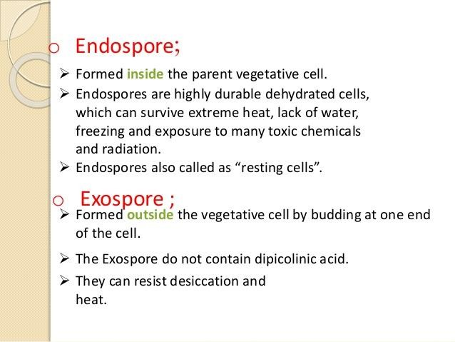

**Dipicolinic acid: is a chemical compound which plays a role in the heat**

**resistance of bacterial endospores**