### **General Pharmacology**

**Pharmacology**: Is a branch in science studies the interaction between substances and living organisms through chemical processes, especially by binding to regulatory molecules and activating or inhibiting normal body processes.

A **drug** can be defined as any substance or products that make changes in biologic function through its chemical actions. Usually, the drug molecule interacts with a specific molecule in the biological system that plays a regulatory role. This molecule is called a receptor.

**Clinical pharmacology** can be defined as the science that studies the clinical actions and applications of the drugs.

Pharmacology studies can be divided into:

* The drug **pharmacokinetics** : represents what the body does to a drug .
* **pharmacodynamics** : represents what the drug does to the body .

Drug concentration at sites of action influenced by several factors, such as:

- Route of administration  
 - Dose  
 - Characteristics of drug molecules (e.g., lipid solubility)

**\* Route of administration**

The route of administration is determined primarily by the properties of the drug (for example, water or lipid solubility, ionization) the therapeutic objectives (for example, the desirability of a rapid onset of action, the need for long-term treatment, or restriction of delivery to a local site). Major routes of drug administration include enteral, parenteral .

A-Enteral

1-Oral

2-Sublingual & Buccal

3-Rectal

B-Parenteral

1-Intravenous (IV)

2-Intramuscular (IM)

3-Subcutaneous (SC)

C-Other  
1-Inhalation  
2-Intranasal

3-Intrathecal/Intraventricular

4-Topical

5-Transdermal

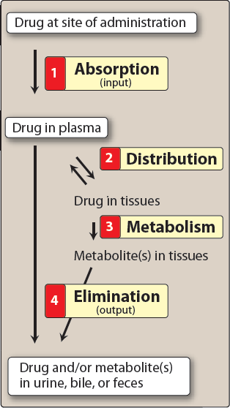

**Dosage forms available for different administration routes:**

**Oral**: liquid, powder, gels, capsules, tablets.

**Topical:** ointment, creams, pastes, gels, liquid.

**Parenteral:** injection, implant, irrigation solutions.

**Respiratory:** inhalation, sprays, gasses.

**Nasal:** liquid, inhalations.

**Eye:** liquid, ointment, creams.

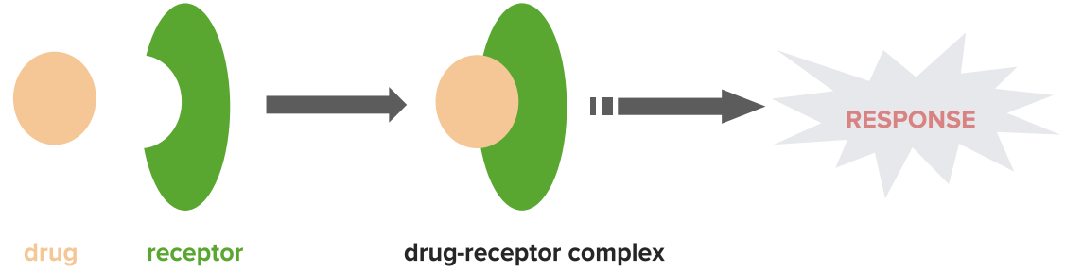



Thank you